Hebrew Language Enrichment Program for Arab Schools
Program Update
The summer opened in July 2019 with a two-day training for inter-sectoral teachers held jointly with Merchavim at Givat Haviva, followed by a joint conference on integration between sectors, “Combine & Integrate,” under the auspices of the Ministry of Education. The conference featured high profile speakers including Tel Aviv-Yafo mayor Ran Huldai, Umm al-Fahm mayor Samir Mahameed, and former Minister of Education Yuli Tamir. In August, preparatory trainings were held for new teachers and pedagogical trainings for veteran teachers.

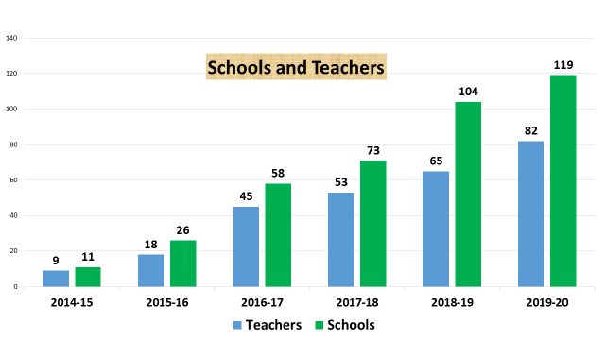
This year the program continued to grow. We now have 82 teachers in 119 schools in five districts, reaching over 32,000 students. The North district has two consultants from the Ministry of Education who visit instructors in the schools and serve as mentors. The Haifa and Central districts have coordinators that assist the supervisors specifically with this program. In the South district, which consists primarily of schools in the Bedouin sector, the district supervisor himself is our point of contact.

Cultivating our relationship with the Ministry has continued to prove critical, as we again faced challenges in teacher placement, this time resulting primarily from a loss of hours to the Arab schools due to a decline in population size, which we needed the Ministry headquarters’ help to resolve. The Ministry’s unflagging support and assistance facilitated eventual placement and gave us hope that the process will be expedited in coming years. The Ministry also appointed a new national referent for the program, Reut Amitai, whose job is to integrate the Hebrew Language instruction in Arab education (Hebrew on the Continuum). She has been intensively learning about the program, its needs, and the challenges faced in the field. On the Ministry’s directive, we transferred our partnership for pedagogical development to Polis, who developed a full year of lesson plans and delivered the trainings to our teachers in August. In the fall, Givat Haviva hosted two conferences for Arab school principals as a favor to the Ministry.

After some difficulty scheduling a sufficient number of Special Hebrew Days and activities toward the end of the school year in recent years due to the timing of Ramadan, this year we encouraged schools to start early. As a result, 47 activities have already been held as of the end of 2019. On November 12, a special day was held at Givat Haviva for the finalists of the short film contest, featuring a stand-up comedian in Hebrew and Arabic and awarding of the top prizes. The winning videos can be seen here:
First place: https://drive.google.com/file/d/1-E4AJSgA84aIFcaLZWfWuc4eRdUBXBFs/view?ts=5d092ded
Second place: https://youtu.be/f8ciEL-i9tk
Third place (tie): https://youtu.be/QZH7jH9A-2Q and https://youtu.be/zAWI-Ip6pQ0
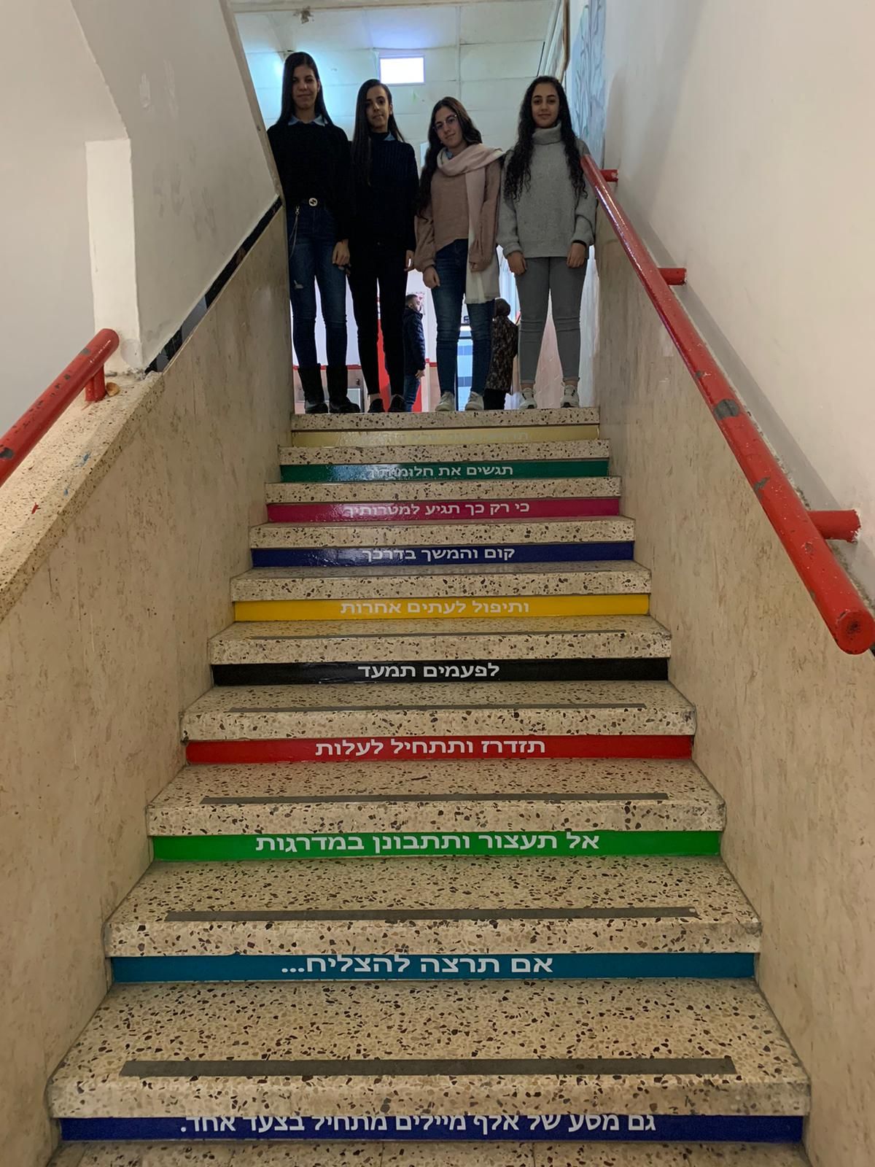
And here is another inspirational video sent by one of the schools, documenting a year-long project of the Yihyeh B’seder Hebrew Language class: https://youtu.be/FgqNIGm8wWY

Below is a calendar of the major program activities from July through December 2019:
July 7-8: two-day training on inter-sectoral integration in education with Merchavim
July 9: inter-sectoral integration in education conference
July: teacher placement in schools begun
Aug 25: training for new teachers form Center, Haifa, and South districts at Givat Haviva
Aug 26: training for same teachers at Givat Haviva by Polis
Aug 27: training for experienced teachers from Center, Haifa, and South districts by Polis at Givat Haviva, and new teacher training in Tamra (North district)
Aug 28: Polis new and experienced teacher training in Tamra (North district)
Sep – Dec: Enrichment activities
Nov 12: Gathering of film contest finalists and awarding prizes
Dec: conclusion of teacher recruitment and placement

The first teacher seminar was held in early January, and preparations are underway for the in-service trainings and the second seminar, as well as our new mentor pairs program, pairing program instructors with Arab colleagues to enhance their professional integration and increase coordination and cooperation.
Students at Elnsour school, first prize winner in the video contest, with an installation funded by the prize.

Givat Haviva’s main lesson from the past six months continues to be the centrality of our relationship with the Ministry of Education on all levels, but particularly at the senior levels, in making possible the program’s full and effective implementation. The program staff continues to be in ongoing, frequent contact with the Ministry, and have just submitted at their request a summary of the state of the program, including the gaps between the Ministry’s commitment and what has occurred on the ground. Reut Amitai, the Ministry official responsible for integration and implementation of the program, has been accompanying the program staff on site visits to the schools, to see clearly what is being done and what is needed. As in previous years, the program staff strives to call on all of the schools in the program. These visits allow the program leadership, as well as any Ministry representatives, to see the teachers firsthand in the schools, to assess what needs should be addressed and how to best meet them, along with the school principal and other faculty.

This year’s evaluation plans to zoom in on the relationship between the program instructors and the rest of the school faculty, particularly the new pairs program, which will include weekend trainings or ongoing seminars for the pairs.

Givat Haviva is working with the Ministry of Education to achieve what was envisaged for the program from the beginning: three consecutive years of spoken Hebrew with a native speaker who is also a representative of Jewish society, with two hours a week per class, from grade seven through nine. Despite the unbroken growth of the program, we still have not reached this objective, which was both our goal and the aspiration shared by the Ministry. We intend and expect to continue our growth and to achieve full implementation for all Arab schools to offer all of the students the maximum potential for academic, vocational, and social integration. The teacher training and support enabled by your support of Givat Haviva is multiplied by a factor of a hundred by the Ministry of Education’s investment in teaching hours.

