Bara’em Hi-Tech Activity Report
January - December 2019

Program Overview
The Bara’em Hi-Tech program at Givat Haviva gives promising Arab high school students in Israel, many from disadvantaged backgrounds, the opportunity to study computer engineering and technology, and earn credits toward a bachelor’s degree in computer science while still in high school. Three features make this program significant and unique:
- The program is offered at a 20% discount, in addition to need-based scholarships available on a case-by-case basis.
- The computer engineering and technology courses are supplemented by Hebrew language enrichment, to bring the students’ language proficiency up to par.
- The program is offered at the Givat Haviva campus, a centrally located space that is not only more accessible, but also a more culturally sensitive and comfortable environment for the Arab Israeli students.

Program Activities
The Bara’em Hi-Tech program at Givat Haviva first opened in October 2015 with a class of 36 ninth grade students. Each year since, the program has commenced with two new full classes (from 76 to 81 students altogether) and a second year class. Successful alumni continue their studies at Netanya Academic College after completing the first two years at Givat Haviva. In November 2019, for the first time, the program opened with three full classes of new students, 118 in all, attesting to its growing reputation. Meanwhile, our oldest students have begun their final year at Netanya, so the very first Bara’em alumni are expected to complete their degrees this summer.
The program runs for three semesters every school year, including an intensive summer semester, with lectures and lab work covering first-year, university-level computer science courses. The courses, identical to those taught at Netanya Academic College, are taught and exams administered by faculty from the Netanya Academic College’s Computer Science Department. The computer courses taught during the first three semesters of year one are “Introduction to Object Oriented Programming”, “Object Oriented Programming”, and “Computer Organization and Threshold Languages”. The courses taught in year two are “Fundamentals of Open Systems”, "Procedural Programming", and "Programming in a Windows Environment".
Bara’em Hi-Tech students face multiple challenges. The technical, university-level course material is inherently challenging. In addition, the computer courses are conducted in Hebrew, the students’ second language. The participants are all highly motivated students who are simultaneously navigating a full, technically oriented course-load in high school. None of the students have the example of an adult family member in hi-tech to look up to or to turn to with questions, and many of the families face serious economic hardships. For this reason, Bara’em Hi-Tech offers students extra support beyond making the academic coursework more accessible physically and financially. The experience of others attempting to open similar programs without this support have demonstrated how imperative it is to our students’ success.
Hebrew language instruction is an intrinsic part of the program. Most years, the Hebrew instruction starts at the beginning of the academic year. This year, however, the majority of students registered for the program very late, so Hebrew instruction will commence in January 2020. Meanwhile, to improve the students’ comprehension, the teaching assistant begins discussion sections by reviewing the terminology with an explanation in Arabic. Givat Haviva also continues to provide extra open lab hours throughout the semesters during which students practice with the teaching assistant available to answer questions and offer individual assistance. Our main teaching assistant is Ahmed Abu Rweishid, who graduated from Netanya with honors and began working with Bara’em Hi-Tech while still a student there. Today he works in industry along with assistant teaching, where he offers instruction and inspiration to other aspiring young Arabs.
Bara'em Hi-Tech students visit Google, Israel. Aug 28. 2019
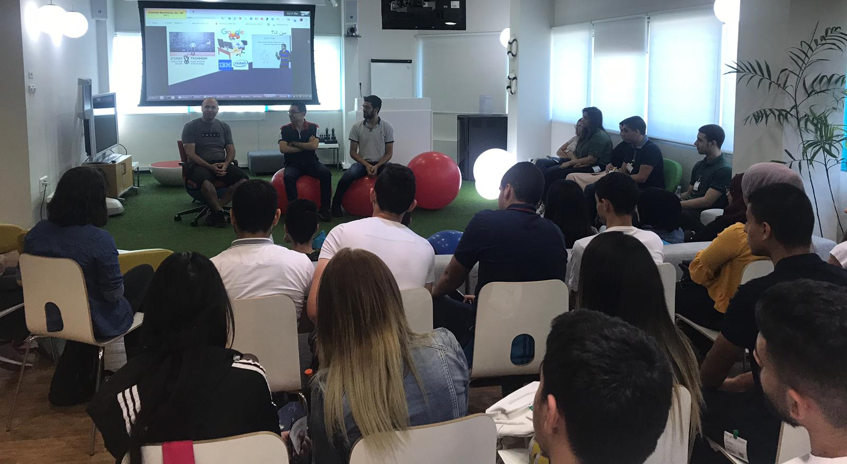
The students went on two field trips during the summer, with first and second year students visiting Google in Haifa, and first year students also visiting Galil software in Nazareth. In December, second and third year students toured Checkpoint in Tel Aviv. These field trips are provided because most of the students have never had an opportunity to see what it is like inside a hi-tech company, making this a significant and meaningful experience for them.
Bara'em Hi-Tecj students at Google Israel, Aug 26, 2019.

Program Evaluation
Retention is an issue in all programs of this type. From private conversations with the heads of programs at Netanya as well as other academic institutions, our project coordinator reports that expected dropout rates of students during or after the first year are 80% or more. This year we achieved our target of 50% retention from year one to year two, and an impressive 73% retention rate into year three, with the transition to Netanya. This year we also surveyed all of our students to assess their needs and how we can improve retention even more.
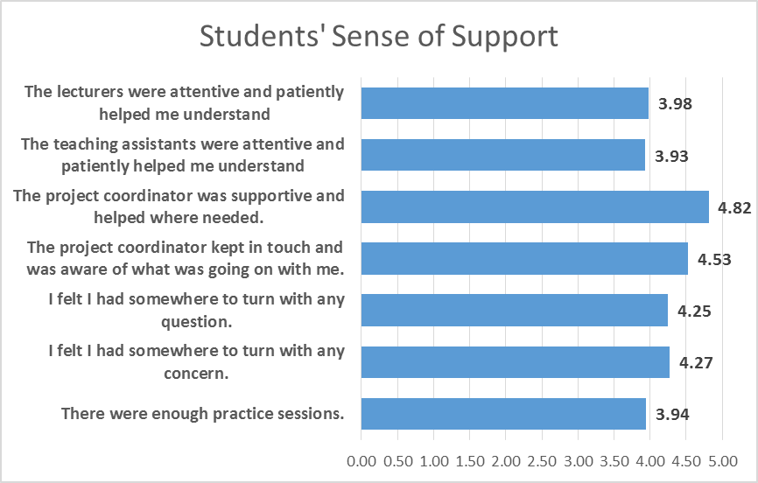
Our evaluation looked for students’ reasons for leaving the program. We also asked them to rate the support they received in Bara’em Hi-Tech. We were not surprised to learn that the difficulty of the material is the primary challenge, followed by families’ ability to pay, even with the financial assistance we provide, indicating a need for ongoing fundraising for an even larger number of need-based scholarships. At present, a full 53% of year 2 students (who were year 1 at the time of the survey) are receiving a significant level of financial assistance.
We were pleased to discover that our project coordinator’s support of the students received the highest ratings, and that students perceived a high level of support from the coordinator, lecturers, and teaching assistants.

Success Stories
Sami and Ibrahim (pseudonyms) are two students from the same neighborhood, who joined the program as ninth graders when it opened in 2015. Today our requirements are more stringent, but at the time they both started with middle school grade averages in the 70s, which did not bode well for their success. In addition, they both came from difficult economic backgrounds: Sami has nine siblings, his father works at odd jobs and his mother as a nursery school assistant. Ibrahim’s father is from Palestine, and has much difficulty finding work in Israel.
They both flunked their first semester with exceedingly low scores (5 and 7 out of 100), after which Yousef, the project coordinator, and the lecturer spoke with them, warning that if they did not make a major effort, they would soon find themselves out of the program. Clearly, they had not realized what they were getting into, and had expected to succeed easily. Yousef continued to keep close tabs on them for the next two semesters, checking that they did their homework and making a weekly plan together with them, teaching them how to manage their time. He made sure they attended extra lessons with the lecturer and the teaching assistant, and assigned one of the best students to mentor them, helping them understand the material and coaching them with the homework.
After that first semester, it was clear that Sami and Ibrahim were getting motivated. They had begun to call Yousef on their own initiative to ask for extra help, they asked the lecturer for help when they didn’t understand, they showed up for all the lessons on time and didn’t miss a minute. They had begun to realize that they would have to work hard to succeed, but also, just as important, that they could. They re-took the exam they had failed and passed the second time. In their second year, their grades were excellent. They worked hard at home and came to all the classes and practice sessions, and the program provided extra hours for them and other students to fully comprehend the material. The lecturers noticed how well they grasped the material and asked them to be teaching assistants and help explain the exercises to other students. After the first year, they received annual awards for outstanding achievement from Netanya Academic College, signifying average scores over 90. Today they are completing high school with an above 90 average as well.
Now Sami and Ibrahim both love their studies, and say that the program has made them more organized and responsible, both academically and personally. They feel they have matured. They want to work in programming, and plan to apply to a Masters’ program at a university or the Technion, although continuing at Netanya Academic College is also an option. They are also exploring internship possibilities.
Sami says the program changed his life. If he had continued as he was before, he may or may not have finished high school, and would probably have joined his father working in construction or cleaning. Many Arab youths spend a few directionless years after high school wondering what to do. Today Sami aspires to complete his Masters’ and work in a global industry. Ibrahim began the program as a small, very introverted boy, who was too shy to raise his hand to ask a question in class. Today he stands in front of classes and explains material, speaking freely and even lecturing. He says, “The program gave me a stronger personality, and also improved my Hebrew. … Studying at Givat Haviva gave me motivation and self-confidence. When I started I was very shy, and I was very scared when I took exams. Today I am self-confident and not afraid of studying and exams.”

